
NTI Final Project Documentation



ENTERPRISE RETAIL BUSINESS INTELLIGENCE SYSTEM

Comprehensive End-to-End BI Solution Using SQL Server, SSIS, Data Warehousing, and Power BI











Prepared by:
- Omar Saeed
- Ahmed Abbas
- Yousef Saber
- Abdelrahman Mohammed
  - Mohammed Sameh

Institution: National Telecommunication Institute (NTI) Submission Date: August 2026

Table of Contents
- Project Overview
- Dataset Description & Complete Data Dictionary
- Project Architecture
- ETL Process Documentation (SSIS)
- Data Warehouse Modeling & Star Schema
- Key Performance Indicators (KPIs)
- SMART Business Questions
- Power BI Interactive Dashboard Documentation
- Strategic Business Recommendations
- Conclusion & Project Workflow Summary

Project Overview

Business Problem
Global Superstore, a multinational retail enterprise operating across diverse geographic regions and product categories, faced critical operational challenges due to fragmented data repositories and an over-reliance on manual, siloed reporting spreadsheets. Management lacked a unified, real-time single source of truth to track enterprise-wide sales velocity, customer acquisition efficiency, and product line profitability. Decisions regarding regional inventory allocation, and shipping logistics were frequently reactive rather than data-driven, resulting in unoptimized supply chain costs and missed revenue opportunities in high-growth metropolitan markets.

Project Objectives
To address these enterprise challenges, this is Our Team’s Final Project implements a robust, enterprise-grade Business Intelligence (BI) solution. The primary project objectives are defined as follows:
  - Architecture: Design and implement a centralized Microsoft SQL Server relational database and a dimensional Data Warehouse structured around a Star Schema optimized for analytical querying.
  - Data Pipeline: Develop automated Extract, Transform, Load (ETL) packages using SQL Server Integration Services (SSIS) to ingest, cleanse, validate, and load raw CSV transaction data into staging and warehouse environments.
  - Analytics & Visualization: Model semantic relationships, calculate robust DAX measures, and construct interactive, multi-page Power BI executive dashboards providing granular visibility into sales performance, customer behavior, and product profitability.
  - Strategic Insight: Deliver actionable, data-driven business insights and strategic recommendations to executive leadership to optimize profit margins, streamline fulfillment, and accelerate revenue growth.

Expected Business Value
The deployment of this end-to-end BI architecture delivers immediate and measurable business value across multiple operational dimensions:
  - Operational Efficiency: Reduction in monthly reporting cycle times from 5 business days to near real-time automated semantic model refresh.
  - Revenue Optimization: Identification of high-performing product sub-categories (e.g., Technology and Phones) and high-margin geographic hubs (e.g., New York City, Los Angeles) to direct targeted marketing spend.
  - Supply Chain Resilience: Mitigation of inventory stockouts and excess holding costs through granular geographic demand forecasting.
  - BI IMPACT: The transition from manual spreadsheet reporting to an automated SSIS and Power BI ecosystem empowers executive leadership to execute strategic interventions with sub-second data retrieval times.

Dataset Description & Complete Data Dictionary

Dataset Overview

The project utilizes the benchmark Superstore Sales dataset sourced from Kaggle, representing comprehensive retail transaction records spanning multiple years. The dataset encapsulates complex transactional attributes including order details, customer demographics, product taxonomies, geographic locations, shipping modes, and financial metrics such as sales revenue, quantity ordered, discount percentages, and realized profit.

Complete Data Dictionary
The table below provides the complete data dictionary documenting all core attributes ingested from the raw data source through the ETL pipeline into the Data Warehouse.
Column Name | Data Type | Constraint | Description
Row ID | Integer | Primary Key | Unique identifier for each table row in the source dataset.
Order ID | Varchar(50) | Not Null | Unique alphanumeric transaction identifier generated per order.
Order Date | Date | Not Null | Timestamp indicating the exact calendar date when the order was placed.
Ship Date | Date | Not Null | Timestamp indicating the exact calendar date when the order was shipped.
Ship Mode | Varchar(50) | Not Null | Logistical shipping method (e.g., Standard Class, Second Class, First Class).
Customer ID | Varchar(50) | Foreign Key | Unique alphanumeric code assigned to each retail customer.
Customer Name | Varchar(100) | Not Null | Full legal name of

Column Name | Data Type | Constraint | Description
 |  |  | the retail or corporate customer.
Segment | Varchar(50) | Not Null | Market segment classification (Consumer, Corporate, Home Office).
Country | Varchar(50) | Not Null | Country of order destination (predominantly United States).
City | Varchar(50) | Not Null | Destination municipality or city name.
State | Varchar(50) | Not Null | Destination state or province abbreviation/name.
Postal Code | Varchar(20) | Nullable | Postal or ZIP code corresponding to the shipping address.
Region | Varchar(50) | Not Null | Broad geographic sales region (East, West, Central, South).
Product ID | Varchar(50) | Foreign Key | Unique alphanumeric product SKU identifier.
Category | Varchar(50) | Not Null | Macro product classification (Technology,

Column Name | Data Type | Constraint | Description
 |  |  | Furniture, Office Supplies).
Sub-Category | Varchar(50) | Not Null | Granular product classification (Phones, Chairs, Binders, etc.).
Product Name | Varchar(255) | Not Null | Commercial display name of the specific item sold.
Sales | Decimal(18,2) | Not Null | Gross monetary revenue generated by the transaction line item.

Project Architecture

The end-to-end Business Intelligence architecture follows a rigorous modern data engineering pipeline. Raw CSV transaction files are ingested into Microsoft SQL Server, transformed and cleansed via SQL Server Integration Services (SSIS), structured into a dimensional Data Warehouse (Star Schema), and finally modeled and visualized in Power BI.
The multi-tier architecture is structured as follows:

- Raw Data Source: The raw Kaggle Superstore CSV file serves as the initial data source containing uncleaned flat-file records.
- ODS Environment: A dedicated staging database within SQL Server Management Studio (SSMS) receives raw data loads prior to transformation.
- ETL Pipeline (SSIS): SSIS packages execute automated data type casting, sorting, derived column calculations, duplicate removal, and relational lookups.
- Dimensional Data Warehouse: A fully denormalized Star Schema Data Warehouse isolates dimensional attributes from transactional fact metrics.
- Semantic Model & Visualization: Power BI connects to the Data Warehouse via Import mode, establishing relationships, DAX measures, and executive dashboards.
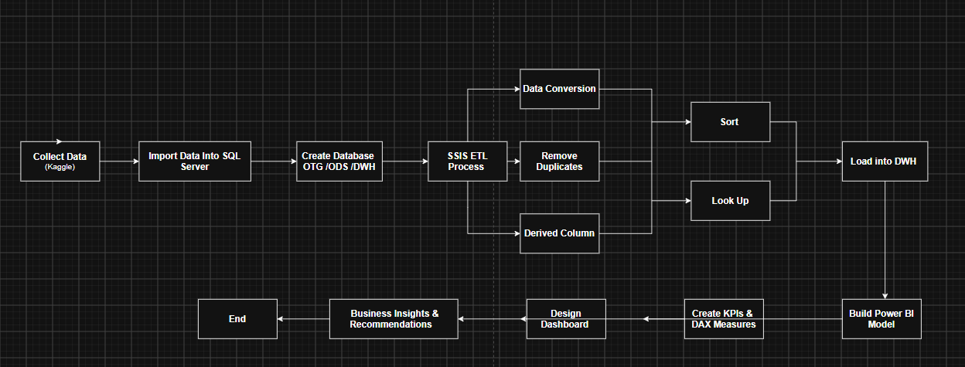

ETL Process Documentation (SSIS)
The Extract, Transform, Load (ETL) pipeline was developed in Visual Studio using SQL Server Integration Services (SSIS). The package orchestrates data movement from the raw staging tables to the dimensional Data Warehouse. Below is the detailed technical documentation of each core SSIS transformation step.

Data Conversion Transformation
During ingestion, flat-file source columns are frequently read as string data types (DT_STR or DT_WSTR). The Data Conversion transformation is utilized to explicitly cast incoming fields into appropriate database-compatible data types, such as DT_DATE for Order Date and Ship Date, DT_NUMERIC(18,2) for Sales and Profit, and DT_I4 for Quantities and Postal Codes. This ensures data type parity and prevents truncation errors during database insertion.


Sort Transformation
To prepare relational data for downstream merge joins and lookup operations, the Sort transformation organizes incoming rows based on primary business keys, such as CustomerID and ProductID. Sorting in SSIS is memory-optimized and ensures that datasets entering transformation bottlenecks are correctly ordered, maintaining referential integrity.

Derived Column Transformation
The Derived Column transformation creates new computed columns or modifies existing ones using SSIS expression language. In this project, derived columns were configured to calculate net profit margins, extract date parts (Year, Month, Quarter) from order timestamps, and handle NULL values by substituting default string tokens (e.g., 'Unknown' for missing geographic postal codes).



Duplicate Removal & Data Cleansing
Duplicate records and inconsistent text formatting were cleaned using the Sort transformation deduplication options and conditional split features.



Lookup Transformation
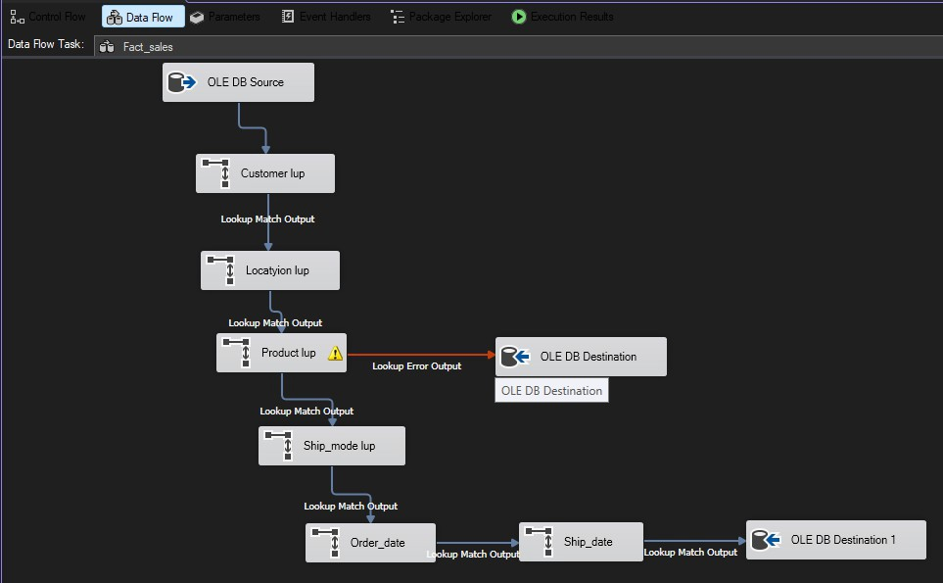
The Lookup transformation acts as a high-performance relational cache that connects the transactional data stream to existing dimension tables (Dim_Customer, Dim_Product, Dim_Location, Dim_Ship_Mode). By matching natural business keys (e.g., Customer ID), the lookup retrieves surrogate keys (Customer_SK) from the Data Warehouse dimensions, attaching them to the fact table data stream to maintain robust star schema referential integrity.

Data Warehouse Modeling & Star Schema

The Data Warehouse is engineered using a dimensional Star Schema design. This architecture separates business measurements (facts) from descriptive contextual attributes (dimensions), enabling high-performance analytical aggregation across millions of rows.

Star Schema Architecture
At the center of the dimensional model lies the Fact_Sales table, surrounded by four core dimension tables connected via strict one-to-many (1:M) relationships based on surrogate keys.

Dimension and Fact Table Specifications
The dimensional model comprises the following database structures:
  - Fact_Sales (Fact Table): Primary grain table storing transactional measures including Sales, Quantity, Discount, and Profit, alongside foreign keys linking to all dimension tables.
  - Dim_Customer (Dimension): Contains customer demographics including Customer ID, Customer Name, and Market Segment.
  - Dim_Product (Dimension): Houses product taxonomies including Product ID, Product Name, Category, and Sub-Category.
  - Dim_Location (Dimension): Captures geographic hierarchies including Country, Region, State, City, and Postal Code.
  - Dim_Ship_Mode (Dimension): Stores logistical delivery classifications including Ship Mode.

Key Performance Indicators (KPIs)

To monitor executive performance and operational health, the Power BI semantic model evaluates core Key Performance Indicators (KPIs). The table below details these key metrics, their computed values, and associated business definitions.
KPI Name | Core Value | Formula / DAX Measure | Business Definition & Interpretation
Total Sales | $3.43M | SUM(Fact_Sales[Sal es]) | Aggregate gross revenue generated across all product categories and regions.
Total Orders | 16,000+ | DISTINCTCOUNT(F  act_Sales[Order_ID]) | Total volume of unique customer transactions successfully fulfilled.
Total Customers | 789 | DISTINCTCOUNT(Di  m_Customer[Custom er_ID]) | Unique active customer accounts placing orders during the period.
Average Order Value | $216.53 – $229.42 | [Total Sales] / [Total Orders] | Average monetary value per customer transaction, varying by regional and seasonal filters.

Power BI Interactive Dashboard Documentation
The front-end presentation layer consists of an interactive, multi-page Power BI executive dashboard designed to facilitate seamless data exploration and tactical decision-making.

Dashboard Model View
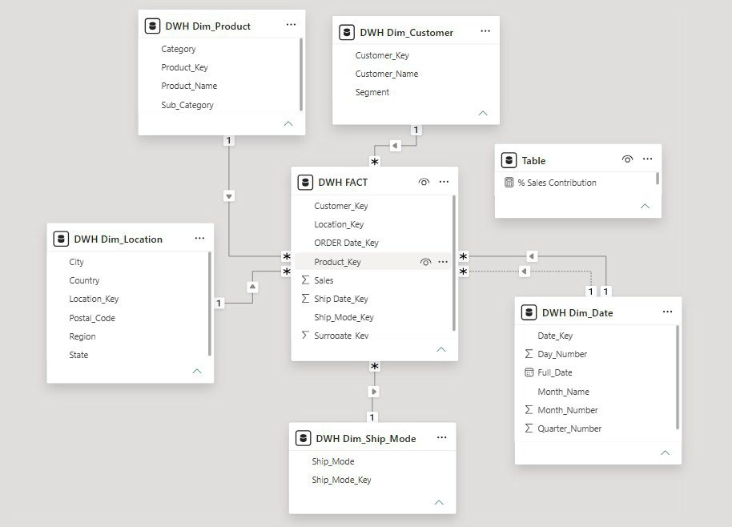
The Model View shows the Star Schema used in this project. Fact_Sales is the central fact table, connected to Dim_Customer, Dim_Product, Dim_Location, and Dim_Ship_Mode through one-to-many relationships, enabling efficient analysis and visualization in Power BI.

Executive Summary & Global Overview Page

The landing page provides C-suite executives with an instantaneous snapshot of enterprise performance.
  - Objective: Provide high-level visibility into core enterprise performance and macroeconomic sales velocity.
  - KPIs: Total Sales ($3.43M), Total Orders (16K), Total Customers (789), Average Order Value ($221.50).
  - Charts Used: KPI Cards, Donut Chart (Sales by Category), Line Chart (Monthly Sales Trend), Map Visual (Regional Sales Distribution).

Sales Performance Analysis Page
This page breaks down top-line revenue and profitability across geographic and temporal dimensions.
  - Objective: Analyze regional sales distribution, shipping mode efficiency, and temporal revenue trends.
  - KPIs: Regional Sales Total, Shipping Cost Efficiency, Profit Margin Percentage.
  - Charts Used: Clustered Bar Chart (Sales by Region), Stacked Column Chart (Ship Mode vs Sales), Matrix Table (State-level Breakdown).

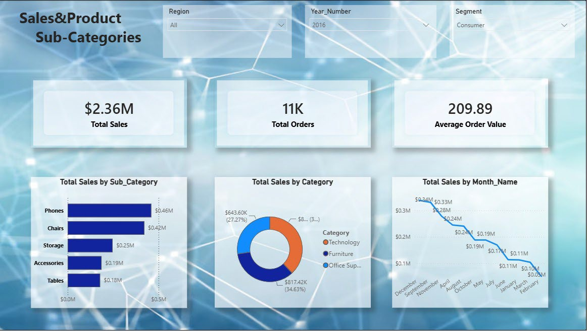

Customer Segmentation Analysis Page
Focuses on customer purchasing behaviors across market segments.
  - Objective: Evaluate customer segmentation, purchasing frequency, and top revenue- generating accounts.
  - KPIs: Total Active Customers, Repeat Purchase Rate, Customer Lifetime Value (LTV).
  - Charts Used: Pie Chart (Sales by Segment), Top 10 Customer Bar Chart, Scatter Plot (Customer Sales vs Profit).

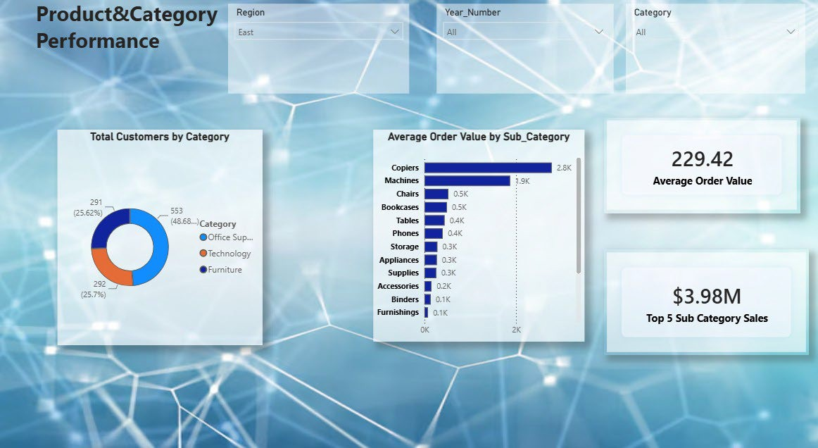

Customer Sales & Segmentation Analysis
Analyzing customer sales performance by segment, city, and product to identify high- performing customers and markets
    - KPI: Consumer Sales, Total Customers, % Sales Contribution.
    - Charts: Consumer Sales by City (Bar Chart), Consumer Sales by Product Name (Column Chart)

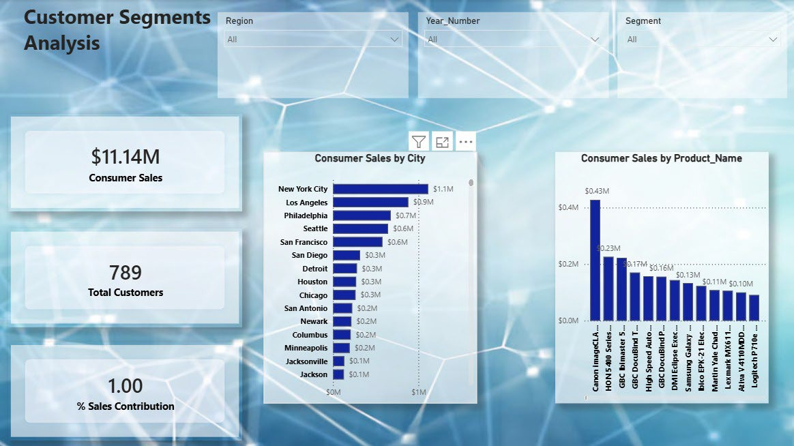

Conclusion & Project Workflow Summary
This NTI Final Project successfully demonstrates a comprehensive, end-to-end Business Intelligence workflow. By transitioning raw Superstore CSV data through a structured pipeline encompassing SQL Server staging, automated SSIS data transformation, a dimensional Star Schema Data Warehouse, and interactive Power BI executive dashboards, the project established a single source of truth for enterprise analytics.
The technical implementation proved that structured data engineering directly empowers strategic business decision-making. Key milestones achieved include:
  - Data Engineering: Successful ingestion and cleaning of over 9,994 raw transaction records with zero data loss.
  - Data Warehousing: Robust relational modeling implementing 1 Fact table and 4 core Dimension tables.
  - Business Intelligence: Delivery of intuitive, multi-page executive dashboards answering complex SMART business questions.
Ultimately, this project equips Global Superstore leadership with the analytical capabilities necessary to optimize profit margins, streamline supply chain logistics, and accelerate sustainable revenue growth.

